This document is tutorials for registration, joining an event, and what can be a host and an attendee do during the event:
Registration tutorial:
Attendees will see the registration link by clicking web-banner or posters provided by the coordinator on www.binus.ac.id/webinar
- Web-banner examples:

Otherwise, the alternative way for attendees that wants to join any events is by opening this following link: www.binus.webex.com

- click “Event Center” tab-menu, and “View Events by Program”. Then click Register

- fill the form and submit it to register to the event.
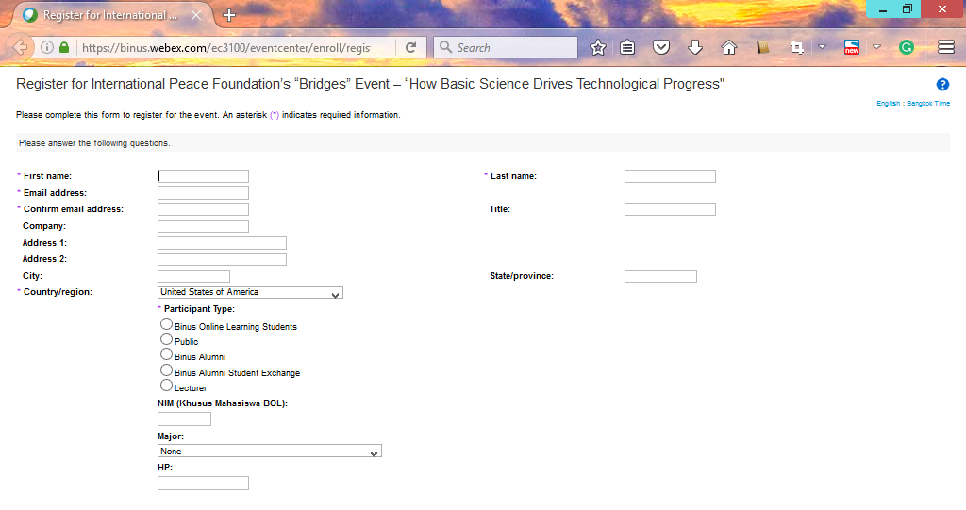

- Attendees will receive a link for joining the event from messenger@webex.com at their email. They can click “click here” or copy-paste the URL to the browser when the event is started.
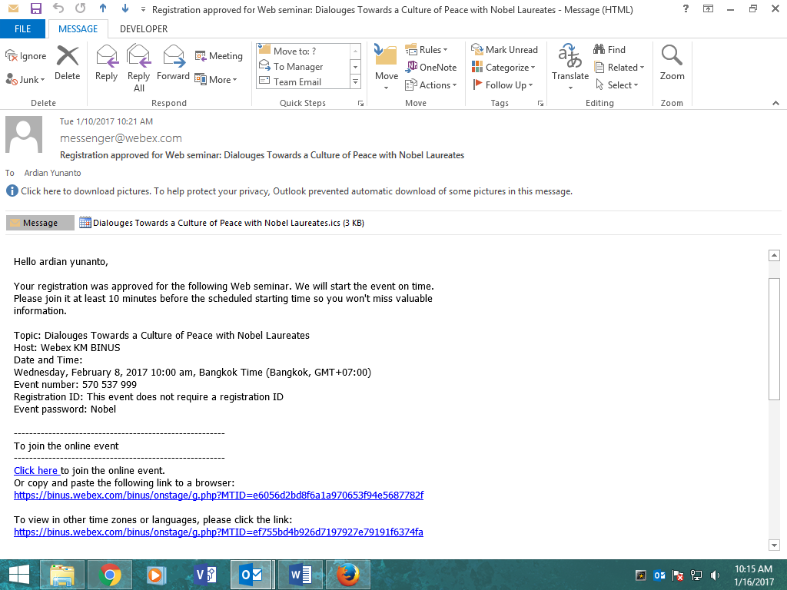

Tutorial when an event is already started:
- This is a display view for attendees when they successfully joined any started event
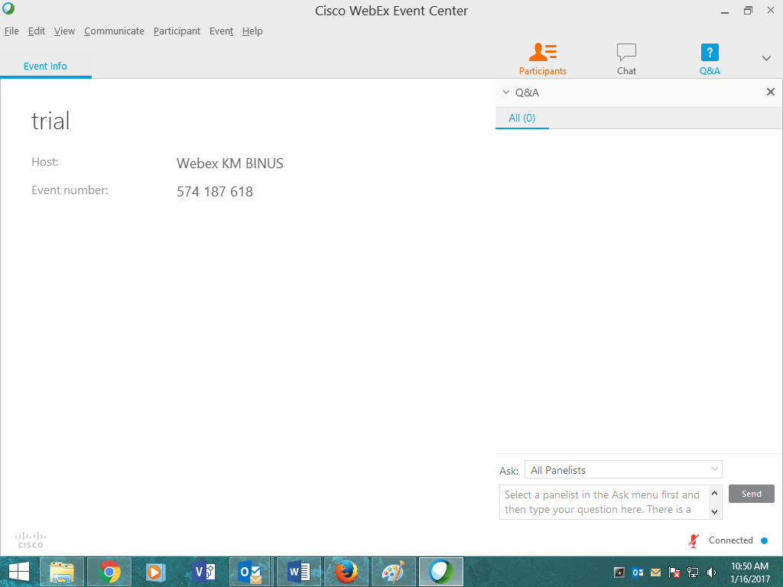

- This is a display view for attendees when the event is sharing presentation file:
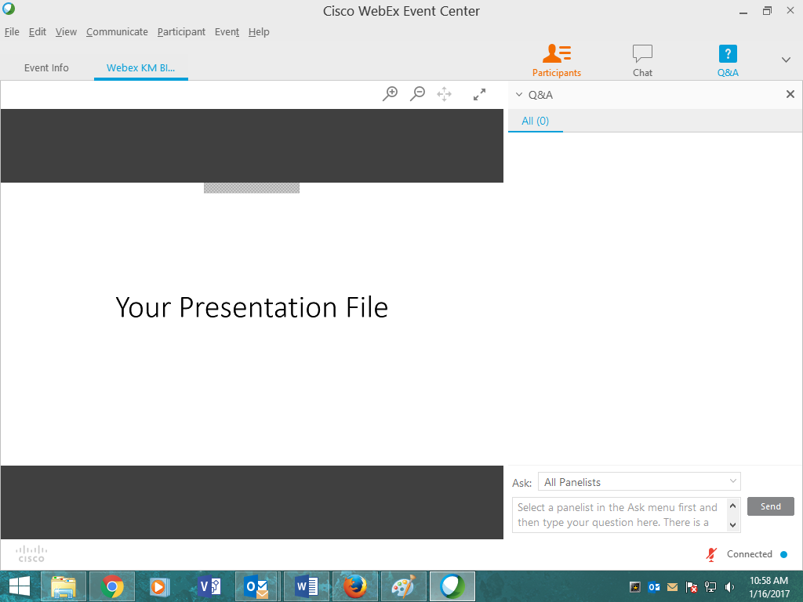

Attendees can also click “participants” button to see the video conference:
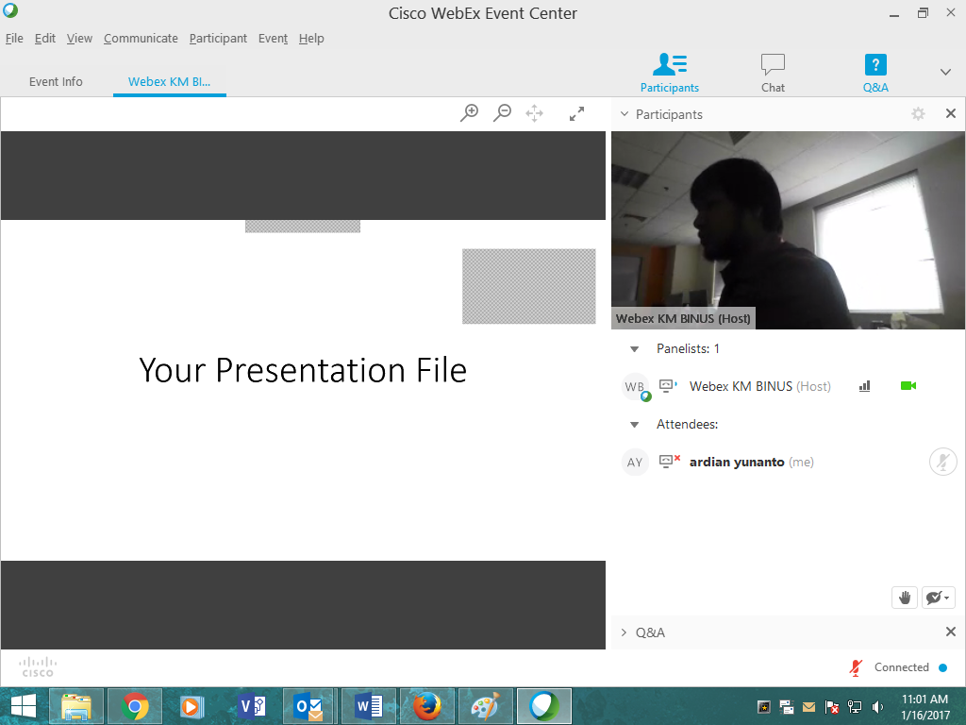

They can also enlarge the video screen by hovering their mouse to the video screen and click an enlarge button
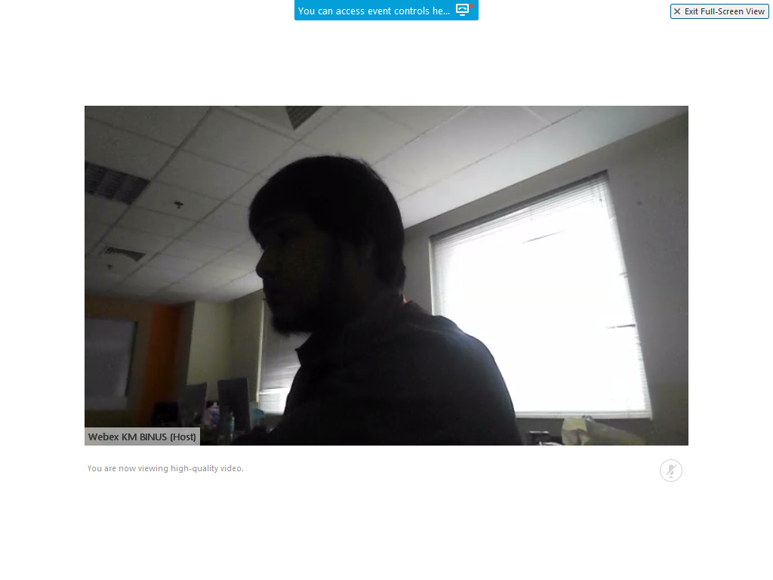

- This is display view for committee. There are 4 roles in webex, namely Host, Panelist, presenter, and Attendee.
Presenter can be used optionally, if the presenter doesn’t want to copy their file(s) to the committee, they must install webex third party in their browser and host can assign the presenter roles to the user in the presenter’s notebook.
Only Presenter can share any application on their PC or notebook to be viewed by the attendees, meanwhile panelist and Host cannot share anything but handle question or chat from others. Presenter can also invite any person to join the event when the event is started. For example, the presenter wants to invite another presenter to join video conference from other country or places to speak. They can send invitation email to join immediately to the webex (the person must have or install webex third party in order to join the event).
Host can create event(s), start an event, end an event, sharing file(s), start video conference, etc. Only Host that can set roles to each user (attendees, presenter, and panelist). By default, host is also has role as presenter.
Panelist can handle chat or question from attendees.
Attendees can’t see other user that joined the event, meanwhile host, presenter, and panelist can. They can view presentation, video conference, and ask question(s) to host, or panelist.

